|  |
| --- |
| **Emotional Face Recognition System Using Python** |
|  |
| ***A report submitted in partial fulfilment of the***  ***requirement for the award of degree of***  ***BACHELORS OF ENGINEERING***  ***in***  ***ELECTRONICS AND COMMUNICATION ENGINEERING*** |
|  |
| ***By*** |
| |  |  | | --- | --- | | **Anmol Gupta** | **19BEC1102** | | **Sushant Kumar** | **19BEC1078** | | **Devesh Sehgal** | **19BEC1082** | | **Paras Kumar** | **19BEC1099** | |
|  |
| *under the guidance of*  ***Dr. Yogendra Narayan*** |
| ***Assistant Professor*** |
| ***Electronics and Communication Engineering*** |
| **Electronics and Communication Engineering**  **UIE, Chandigarh University** |

**Table of Contents**

[Acknowledgement i](C:\\Users\\Sush\\Downloads\\l)

Abstract ii

List of Figures iii

List of Tablesiv

**Chapter** **1.** **Introduction**

**Chapter** **2.** **Problem Identification**

2.1 Existing model

**Chapter 3. Design Flow**

3.1 **Flow Chart**

**3.2 Software Require**

**3.3 Hardware Required**

**Chapter 4. Simulation and Outcome**

**Chapter 5. Conclusion and Future**

**References**

**Cost Analysis**

**ECE Archives Project Submission Form**

**Acknowledgment**

I really appreciate that I have such an opportunity to express my great gratitude and respect to people who helped me when I prepared my BE project. Without their support and encouragement I cannot go so far.

It is difficult to overstate my greatest gratitude to my project mentor Dr. Yogendra Narayan, Assistant Professor, ECE Department. First, I would like to thank him for their patient guidance and inspiration throughout my study period. Secondly, I highly appreciate their encouragement and support in my project work, which helped me build confidence and courage to overcome difficulties. Finally, I am grateful for their great insight and suggestions and sharing so much time in project completion. I would have been lost without their support.

I am as ever, truly and deeply indebted to Prof. (Dr.) S. S. Sehgal, Executive Director, and Prof. (Dr.) Paras Chawla, Head of ECE Department for their great support at every stage of my academic life, and longed to see this achievement come true.

**Abstract**

● Detecting the real-time emotion of the person with a camera input is one of the advanced features in the machine learning process. The detection of emotion of a person using a camera is easiest and best way to do this The detection of emotion is made done by the machine learning . we used the trained dataset to detect the emotion of the person. For detecting the different emotions, first we needed to train the algorithm those different emotions

● In this article, we will discuss creating a Python program to detect the real- time emotion of a human being using the camera.

# Group Members

|  |  |
| --- | --- |
| **Anmol Gupta** | **19BEC1102** |
| **Sushant Kumar** | **19BEC1078** |
| **Devesh Sehgal** | **19BEC1082** |
| **Paras Kumar** | **19BEC1099** |

# Chapter 1

As we know that people are digging under Anxiety, Depression and Bad mood swings, etc… So, now we are coming with this project, it makes people Happy and turns their sadness into calmness and happy vibes. And we are planning to introduce this project as a Patent soon. So that we figure out the Market need and make it easily available and easier to use as a Device.

**1.1 Team Description**

After lots and lots of meets and discussions we were able to brainstorm the problem faced by the people having difficulty in communication, it was hard to come up with something which has to be as much cheap plus easy to make and further easy to install for the right usage especially when it comes to special cases such as autism where the individual is unable to share problems which sometimes can lead to problems, in the end we decided to focus on the problem in stages and the first stage being the recognition of facial emotions and then from there slowly integrate the project up to the completion

We divided the tasks for the project gradually and everyone contributed as much they could and did all the task assigned to them to be able to solve the problem and shaped the solution and make it viable..

**1.2 Objectives**

By several intensive subjective evaluation studies and articles we found that Human facial expressions are one of the most important non-verbal ways we communicate. With 43 different muscles we our capable of making more than 27 expressions,

Here’s a rundown of those seven universal emotions, what they look like, and why we're biologically hardwired to express them this way:

Anger

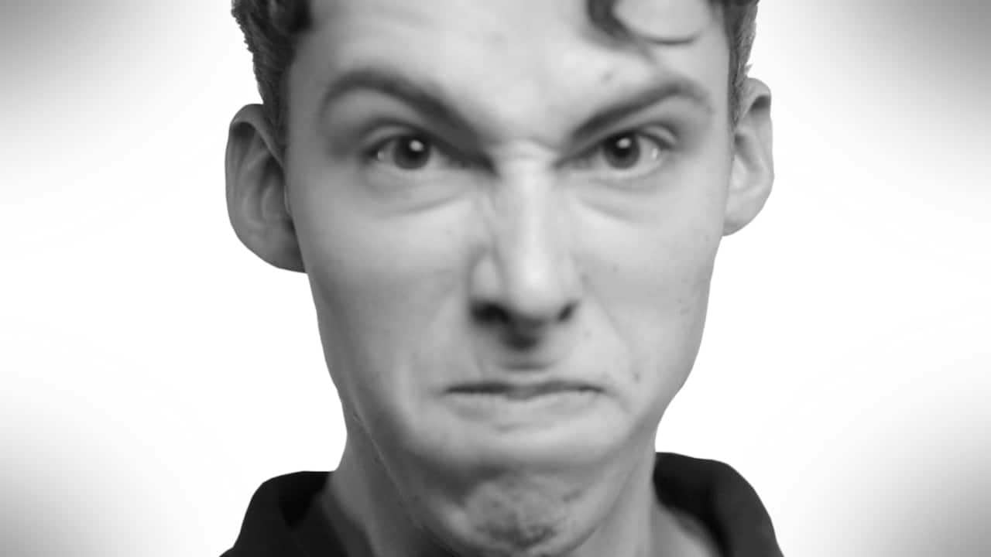

**Facial movements:**Eyebrows clenched down with lower eyelids and upper eyelids pulled up, lips rolled in and tightened.

##### Anger face works well because each facial movement makes a person seem physically stronger, according to various research papers and studies this face lets the threat know we are a threat. It's is the most intimidating emotion and it shows just how expressive and deep the human face can be. It serves as a warning, it’s simply to intimidate or to show that a conflict has begun.

Fear

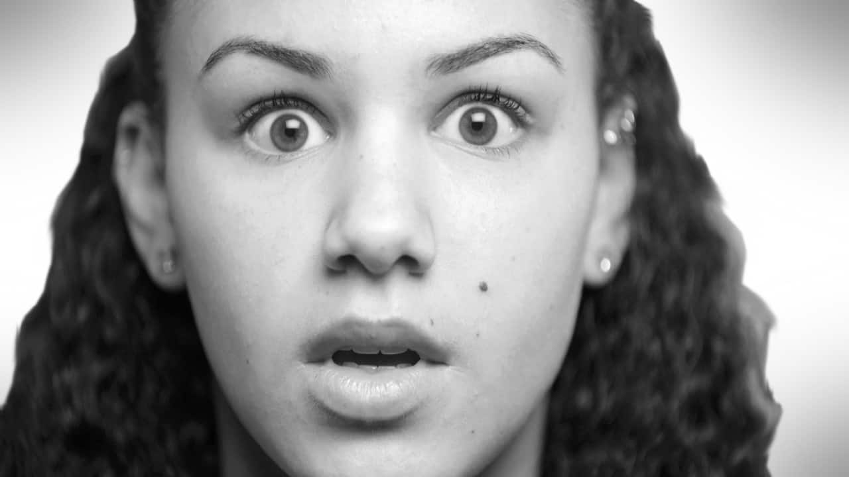

**Facial movements: with mouth stretched, Eyebrows pulled up and together,**

**Fear-based facial movement prepares an individual for the fight-or-flight response. This facial expression displays off of the way our bodies work. Widening our eyes opens out FOV and lets us observe more things by letting in more light. The same can be said for our lungs and oxygen pathways Opening our nostrils increases our air intake letting more oxygen in and helps us prepare to flight or fight.**

Disgust

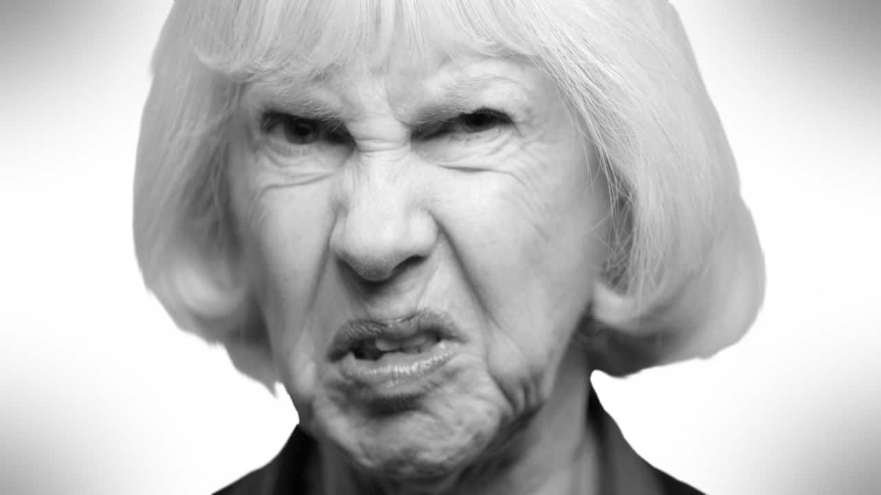

**Facial movements: With nose getting wrinkly and upper lip pulled up and eyebrows pulled down**

**The disgusting face not only shows our distaste but also protects us. pressing the nose closes the nasal passage hence blocking it from dangerous fumes and closing our eyes protects them from possible damage.**

Happiness

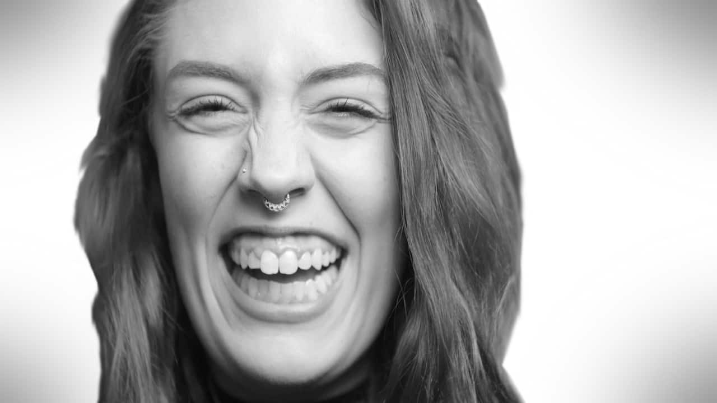

**Facial movements: “crows feet” wrinkles around the eyes with Muscle around the eyes tightened, cheeks raised, lip corners raised diagonally.**

**Regardless of it being friendly connotation, it is believed our smiles might have a more sinister origin. Majority of the primates show their teeth to assert their dominance and their status in their social structure. Some researchers believe it is that it eventually evolved into a smile.**

Sadness

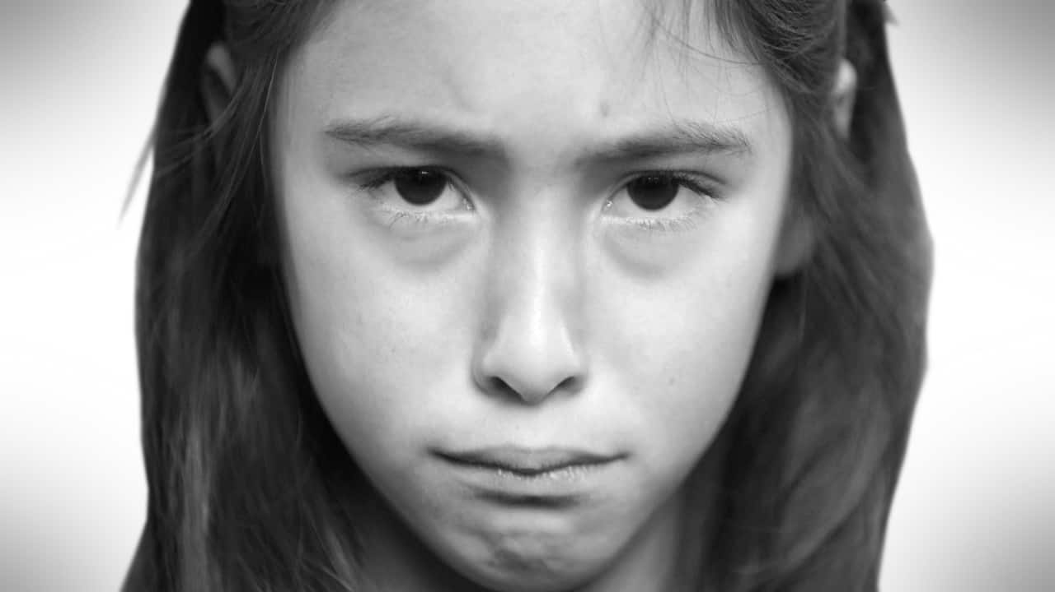

**Facial movements: eyelids lose, lip corners pulled down. Inner corners of eyebrows raised,**

**Sadness is hard to fake and according to researchers. One of the signs of sadness is the inner-brow raised which is very hard to fake and few people can do knowingly**

Surprise

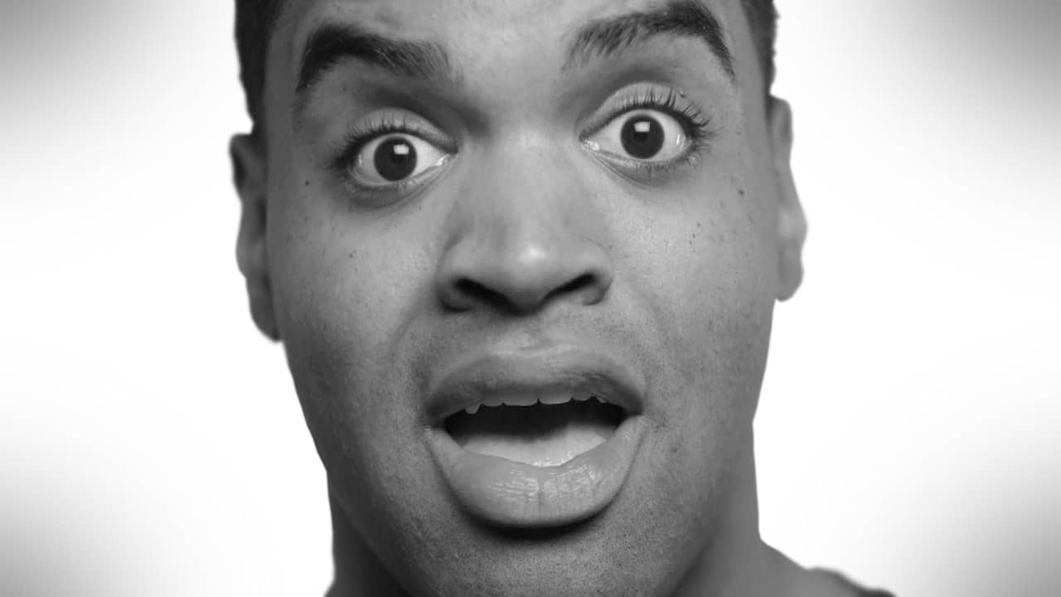

**Facial movements: mouth hangs open with dilated pupils with eyelids pulled up and Entire eyebrow pulled up**

**While the surprise expression may last for few moments, the facial movements — particularly the raised eyebrows — allow us to take our surroundings, shift our attention to another, possibly bad event and react quicker. Regardless of it being good or bad the facial reaction is the same when it comes to surprise**

Contempt

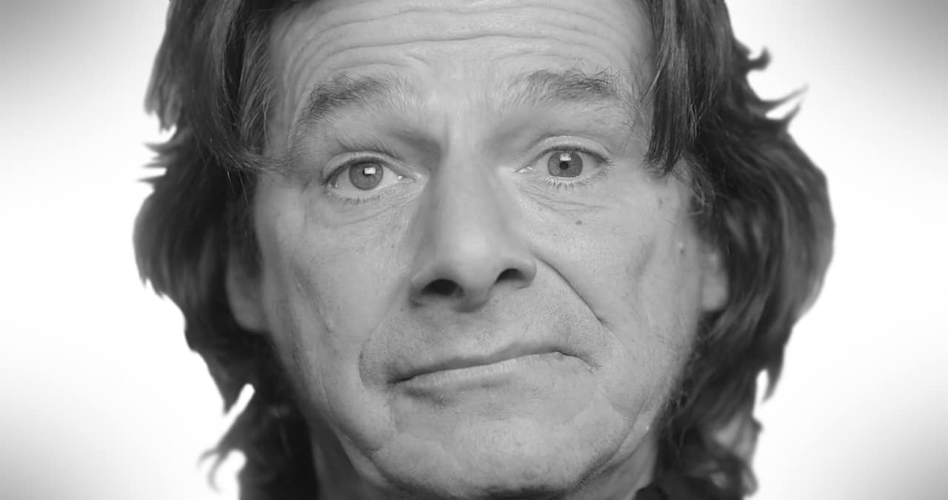

**Facial movements: Neutral eyes with no reaction and corner of the lips pulled up and back on one side.**

**Although contempt as an emotion can be similar to anger and distrust, this expression is unique and very interesting. It is the only expression that affects one side of the face and can be of variable intensity. At its peak, one brow lowers down while the lower eyelid and lip corner gets raised on the same side. At its most sneak, the lip corner only raises up for a brief moment of time briefly. Compared to voice-only detection. When the audio track of each emotion clip is edited with a different type of voice expression or emotional expression, still anger, happiness, and surprise were more observable in the video. However, the dislike emotion gave wired and mixed responses for different speakers. As conclusion, a facial emotion recognition system using python is much effective and promises better accuracy**

**With the advent of the Emotional Face Recognition System Using Python, it’s now easier than before to verify the identity of a person's emotions. Emotional Face recognition can be applied in many fields, one being smart devices and eco-friendly applications that will change the mood of a person easily. With known faces captured in a database, the device will identify the emotions on your face. We can also use this system in Cars, homes to make daily life easier with calmness and happiness.**

**1.3 Detailed Project**

Detecting the emotions of the person with a video camera on a phone or a laptop or similar things is one of the advanced and easy features in the machine learning process. The detection of the emotion of an individual using a camera is useful for various research and day-to-day needs. The detection of emotion is made by using the ML concept. We learn the algorithm to detect the emotion of humans. For detecting the different emotions we first need to train those different emotions

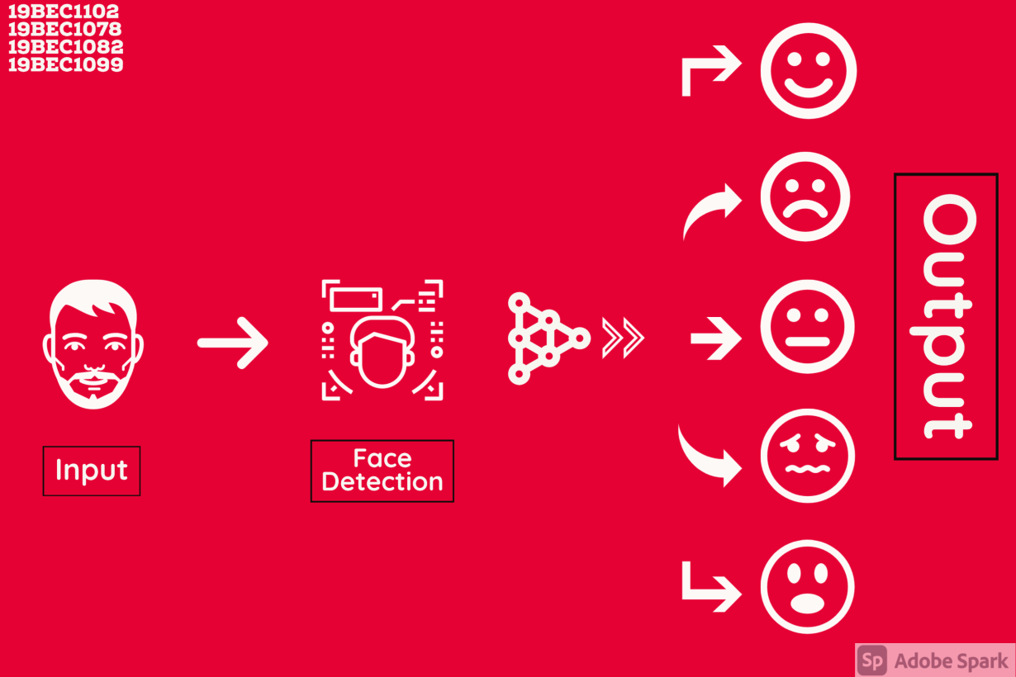

**Chapter 2**

**Problem Identification**

**2.1 Existing Product/ Process**

|  |  |  |  |
| --- | --- | --- | --- |
| **Year** | **PROJECT/ INVENTION**  **NAME** | **AUTHOR/INVENTOR**  **NAME** | **FEATURES/OBJECTIVES** |
| 2019 | **Emotional recognition with wearable EEG device** | [Akihito](https://ieeexplore.ieee.org/author/37087060351)  [Suzuki](https://ieeexplore.ieee.org/author/37087060351); [Hidekatsu](https://ieeexplore.ieee.org/author/37087058487) [Ito;](https://ieeexplore.ieee.org/author/37087058487) [Masaki Ishii](https://ieeexplore.ieee.org/author/37962582500); [Kohji](https://ieeexplore.ieee.org/author/37846844700) [Dohsaka](https://ieeexplore.ieee.org/author/37846844700) | To elucidate relationships between changes in brain activity associated with emotional image presentation, EEG spectra were analysed in the resting state and during Positive or Negative image presentation using wearable electrical encephalogram (EEG) device and custom image presentation software developed in  Our laboratory. |
| 2017 | **Emotion recognition system based on physiological signals with Raspberry Pi III implementation** | [Mimoun Ben Henia](https://ieeexplore.ieee.org/author/37086091669) [Wiem](https://ieeexplore.ieee.org/author/37086091669); [Zied Lachiri](https://ieeexplore.ieee.org/author/37832340000) | Human machine interaction field has potential applications in different domains such as medicine therapies for vulnerable persons. Thus, allowing the machine to identify and understand emotional states is one of the primordial stages for affective interactivity with Humans. Recent studies have proved that  physiological signals contribute to recognize the emotion |
| 2018 | **Automatic Facial Expression Recognition Using DCNN** | [VeenaMayya Radhika](https://www.sciencedirect.com/science/article/pii/S1877050916314752#!) | a novel method for automatically recognizing facial expressions using Deep Convolutional Neural Network(DCNN) features is  proposed. |
| 2019 | **Emotion recognition and drowsiness detection using Python** | [Anmol Uppal](https://ieeexplore.ieee.org/author/37086921425); [Shweta](https://ieeexplore.ieee.org/author/37086920063) [Tyagi](https://ieeexplore.ieee.org/author/37086920063); [Rishi](https://ieeexplore.ieee.org/author/37085810682)  [Kumar](https://ieeexplore.ieee.org/author/37085810682); [Seema Sharma](https://ieeexplore.ieee.org/author/37086919262) | The objective of the project is to be an affordable and efficient product. Artificial Intelligence & Digital image processing technology used to make the system in python. Detection of eye blinking is important in certain scenarios where to avoid any accident or mishappening like in  vehicles or in security vigilance. |

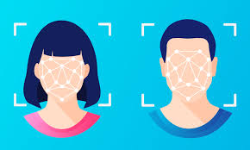 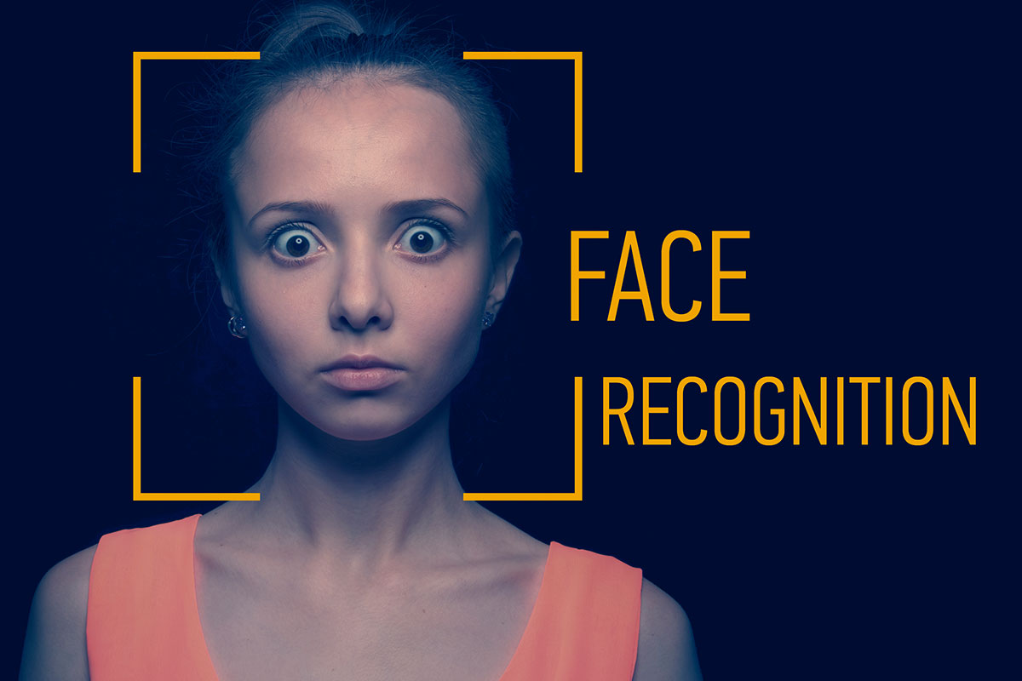

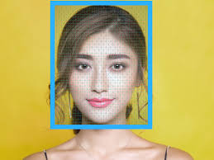

**Chapter 3**

**Design Flow and Tools**

* Face recognition is a broad problem of identifying or verifying people in photographs and videos.
* Face recognition is a process comprised of detection, alignment, feature extraction, and a recognition task
* Deep learning models first approached then exceeded human performance for face recognition tasks.

**Software Required**

Anaconda which is distribution of the Python and R programming languages for scientific computing it provided us a stable platform with plethora of tools and libraries which were essential for this project

Python (*Python is a high-level general-purpose programming language*) was Utilised as the main programming language

The basic flowchart of the process can be observed in the figure below

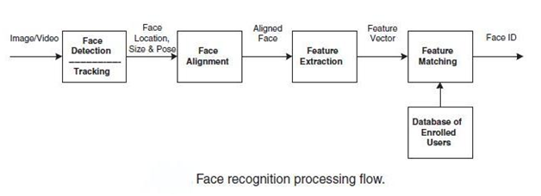

In this project, we applied face detection to some files we uploaded in the program, and using OpenCV with Python it learned the ML. OpenCV is an open-source python library that allows coders to access Application Programming Interface routines for computer applications. Object Detection using Haar feature-based cascade classifiers is an effective face and object detection method

If we take a look at the algorithm, the algorithm initially needs a lot of positive images (images of faces) and negative images (images without faces) to train the classifier. Then we need to extract features from it. For this, Haar features shown in the below image are used. They are just like our convolutional kernel. Each feature is a single value obtained by subtracting the sum of pixels under the white rectangle from the sum of pixels under the black rectangle.

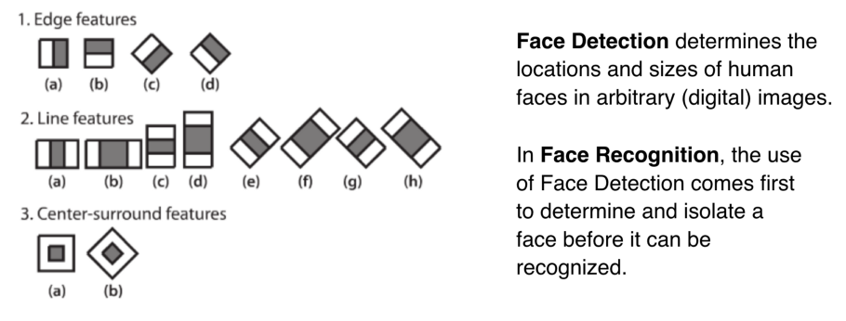

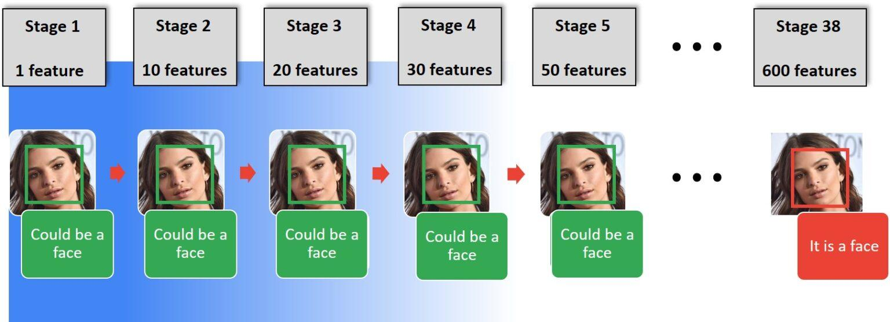

After the successful implementation of the algorithm, next step is to use the algorithm to detect faces and emotion in real time world via the pictures or video input

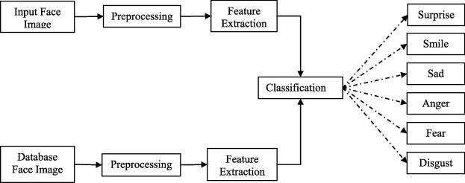

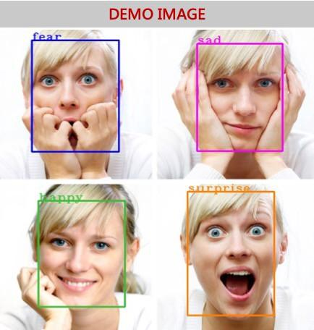

**Chapter 4**

**Simulation and Outcome**

This Project is divided into two major parts

* Training the Database

For training purposes, we use the predefined in trained dataset CSV file as our main input for my input for training the machine.

**Code:**

*import sys, os*

*import pandas as pd*

*import numpy as np*

*from keras.models import Sequential*

*from keras.layers import Dense, Dropout, Activation, Flatten*

*from keras.layers import Conv2D, MaxPooling2D, BatchNormalization,AveragePooling2D*

*from keras.losses import categorical_crossentropy*

*from keras.optimizers import Adam*

*from keras.regularizers import l2*

*from keras.utils import np_utils*

*# pd.set_option('display.max_rows', 500)*

*# pd.set_option('display.max_columns', 500)*

*# pd.set_option('display.width', 1000)*

*df=pd.read_csv('fer2013.csv')*

*# print(df.info())*

*# print(df["Usage"].value_counts())*

*# print(df.head())*

*X_train,train_y,X_test,test_y=[],[],[],[]*

*for index, row in df.iterrows():*

*val=row['pixels'].split(" ")*

*try:*

*if 'Training' in row['Usage']:*

*X_train.append(np.array(val,'float32'))*

*train_y.append(row['emotion'])*

*elif 'PublicTest' in row['Usage']:*

*X_test.append(np.array(val,'float32'))*

*test_y.append(row['emotion'])*

*except:*

*print(f"error occured at index :{index} and row:{row}")*

*num_features = 64*

*num_labels = 7*

*batch_size = 64*

*epochs = 30*

*width, height = 48, 48*

*X_train = np.array(X_train,'float32')*

*train_y = np.array(train_y,'float32')*

*X_test = np.array(X_test,'float32')*

*test_y = np.array(test_y,'float32')*

*train_y=np_utils.to_categorical(train_y, num_classes=num_labels)*

*test_y=np_utils.to_categorical(test_y, num_classes=num_labels)*

*#cannot produce*

*#normalizing data between oand 1*

*X_train -= np.mean(X_train, axis=0)*

*X_train /= np.std(X_train, axis=0)*

*X_test -= np.mean(X_test, axis=0)*

*X_test /= np.std(X_test, axis=0)*

*X_train = X_train.reshape(X_train.shape[0], 48, 48, 1)*

*X_test = X_test.reshape(X_test.shape[0], 48, 48, 1)*

*# print(f"shape:{X_train.shape}")*

*##designing the cnn*

*#1st convolution layer*

*model = Sequential()*

*model.add(Conv2D(64, kernel_size=(3, 3), activation='relu', input_shape=(X_train.shape[1:])))*

*model.add(Conv2D(64,kernel_size= (3, 3), activation='relu'))*

*# model.add(BatchNormalization())*

*model.add(MaxPooling2D(pool_size=(2,2), strides=(2, 2)))*

*model.add(Dropout(0.5))*

*#2nd convolution layer*

*model.add(Conv2D(64, (3, 3), activation='relu'))*

*model.add(Conv2D(64, (3, 3), activation='relu'))*

*# model.add(BatchNormalization())*

*model.add(MaxPooling2D(pool_size=(2,2), strides=(2, 2)))*

*model.add(Dropout(0.5))*

*#3rd convolution layer*

*model.add(Conv2D(128, (3, 3), activation='relu'))*

*model.add(Conv2D(128, (3, 3), activation='relu'))*

*# model.add(BatchNormalization())*

*model.add(MaxPooling2D(pool_size=(2,2), strides=(2, 2)))*

*model.add(Flatten())*

*#fully connected neural networks*

*model.add(Dense(1024, activation='relu'))*

*model.add(Dropout(0.2))*

*model.add(Dense(1024, activation='relu'))*

*model.add(Dropout(0.2))*

*model.add(Dense(num_labels, activation='softmax'))*

*# model.summary()*

*#Compliling the model*

*model.compile(loss=categorical_crossentropy,*

*optimizer=Adam(),*

*metrics=['accuracy'])*

*#Training the model*

*model.fit(X_train, train_y,*

*batch_size=batch_size,*

*epochs=epochs,*

*verbose=1,*

*validation_data=(X_test, test_y),*

*shuffle=True)*

*#Saving the model to use it later on*

*fer_json = model.to_json()*

*with open("fer.json", "w") as json_file:*

*json_file.write(fer_json)*

*model.save_weights("fer.h5")*

* Detecting Real-Time Emotion

For detecting the emotion, first, you need to run the train.py program to train the data. Then you can use the code given below:

**Code:**

*import cv2*

*import numpy as np*

*from keras.models import model_from_json*

*from keras.preprocessing import image*

*import pygame*

*from pygame import mixer*

*model = model_from_json(open("fer.json", "r").read())*

*model.load_weights('fer.h5')*

*face_haar_cascade = cv2.CascadeClassifier('haarcascade_frontalface_default.xml')*

*cap=cv2.VideoCapture(0)*

*while True:*

*ret,test_img=cap.read()*

*if not ret:*

*continue*

*gray_img= cv2.cvtColor(test_img, cv2.COLOR_BGR2GRAY)*

*faces_detected = face_haar_cascade.detectMultiScale(gray_img, 1.32, 5)*

*for (x,y,w,h) in faces_detected:*

*cv2.rectangle(test_img,(x,y),(x+w,y+h),(255,0,0),thickness=7)*

*roi_gray=gray_img[y:y+w,x:x+h]*

*roi_gray=cv2.resize(roi_gray,(48,48))*

*img_pixels = image.img_to_array(roi_gray)*

*img_pixels = np.expand_dims(img_pixels, axis = 0)*

*img_pixels /= 255*

*predictions = model.predict(img_pixels)*

*max_index = np.argmax(predictions[0])*

*emotions = ('Angry', 'Disgust', 'Fear', 'Happy', 'Sad', 'Surprise', 'Neutral')*

*predicted_emotion = emotions[max_index]*

*cv2.putText(test_img, predicted_emotion, (int(x), int(y)), cv2.FONT_HERSHEY_SIMPLEX, 1, (0,0,255), 2)*

*print (predicted_emotion)*

*if predicted_emotion == ("Sad"):*

*mixer.init()*

*mixer.music.load("1.mp3")*

*mixer.music.set_volume(0.3)*

*mixer.music.play()*

*elif predicted_emotion == ("Happy"):*

*mixer.init()*

*mixer.music.load("2.mp3")*

*mixer.music.set_volume(0.3)*

*mixer.music.play()*

*elif predicted_emotion == ("Angry"):*

*mixer.init()*

*mixer.music.load("3.mp3")*

*mixer.music.set_volume(0.3)*

*mixer.music.play()*

*elif predicted_emotion == ("Fear"):*

*mixer.init()*

*mixer.music.load("4.mp3")*

*mixer.music.set_volume(0.3)*

*mixer.music.play()*

*resized_img = cv2.resize(test_img, (1000, 700))*

*cv2.imshow('Facial emotion analysis ',resized_img)*

*if cv2.waitKey(10) == ord('q'):*

*break*

*cap.release()*

*cv2.destroyAllWindows*

**Output:**

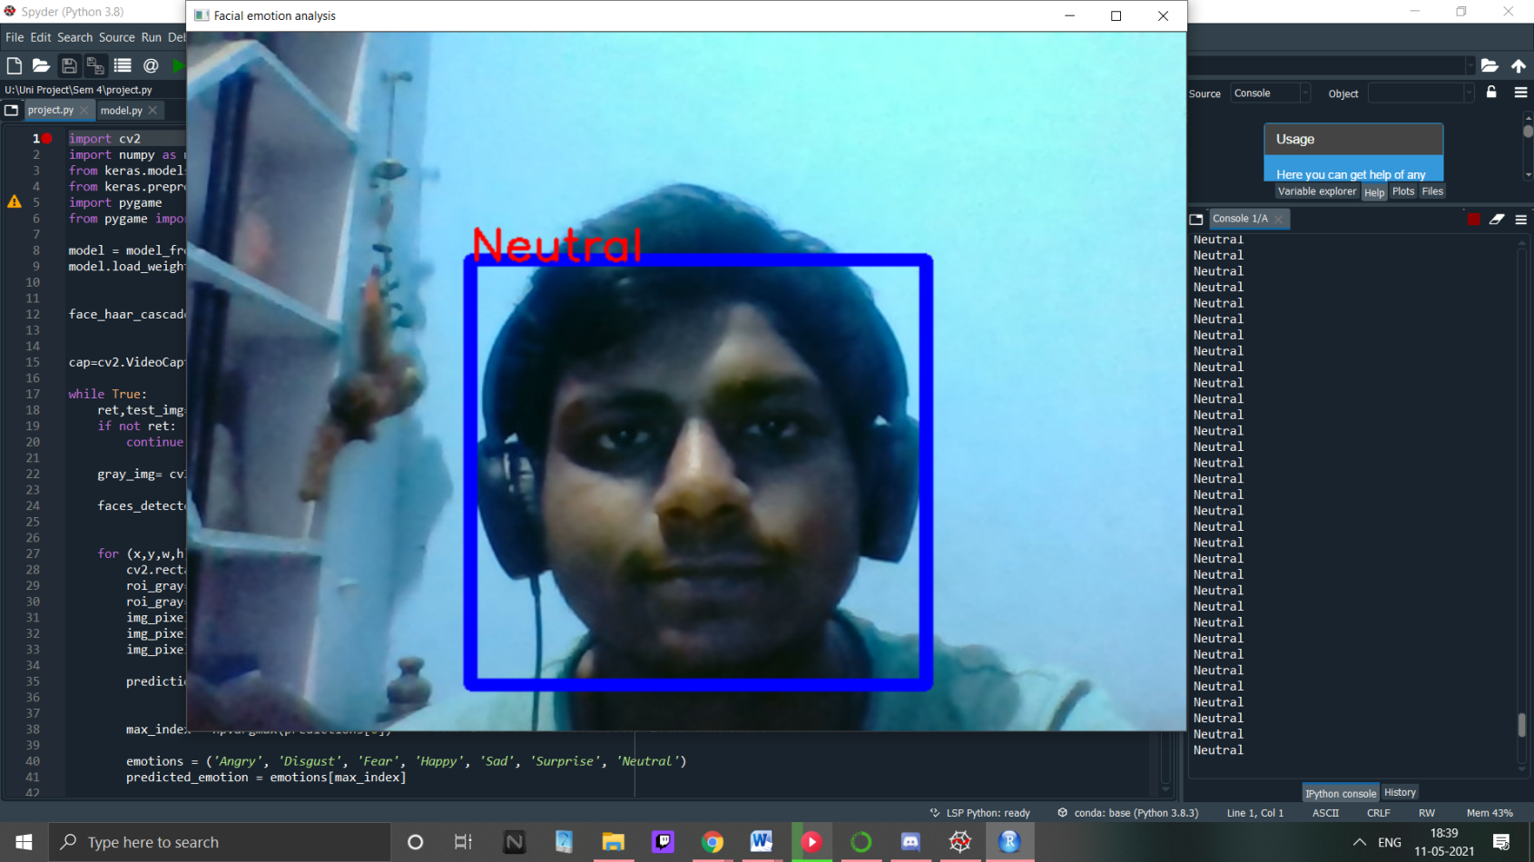

**4.3 Weekly Report**

As from the starting of the semester, our project lecture has been weekly organized; we have made progressions every week. Every week was full of new learning, group meets and discussions over finding the best possible solution for the problem identified and progress possible to get the best design and technical integration possible.

And here we avail our Weekly Report of Progress.

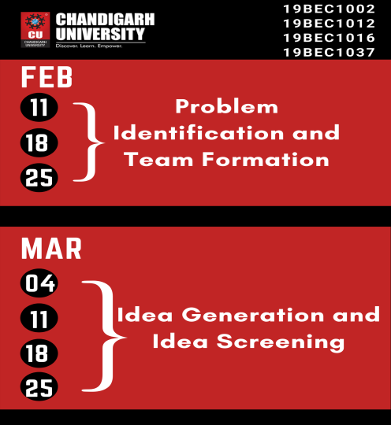 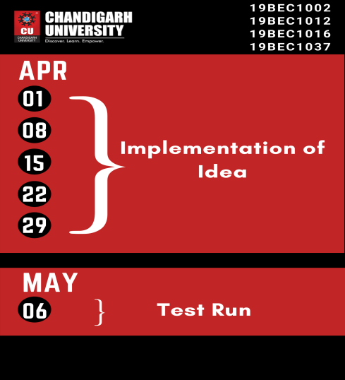

**Figure 4.3: Weekly Report Poster**

|  |  |  |
| --- | --- | --- |
| **4.3 Weekly Report** | | |
| Feb | **11th Feb** | Finalize the Idea |
| **18th Feb** | Prepare a team of 4 members |
| **25th Feb** | Reconsider the Idea and assign the task to each and every member of a group |
| March | **4th March** | Proper Implementation of idea |
| **11th March** | Build up the basics plans and complete the phase 1 task |
| **18th March** | Software work and go for the further tasks |
| **25th March** | Debug the software and successfully complete the code |
| April | **1st April** | Whole Discussion about components |
| **8th April** | Proper testing of Project |
| **15th April** | Designing the circuit design and test on online simulation |
| **22th April** | Problem solving and sort the difficulties in Hardware design |
| **29th April** | Testing Our device and prepare the report for the project |
| **May** | **6th May** | Finalize the Project Report |

**Table 4.3: Weekly Report**

**Chapter 5**

**Conclusion and Future Scope**

**5.1 Conclusion**

**5.2 Future Scope**

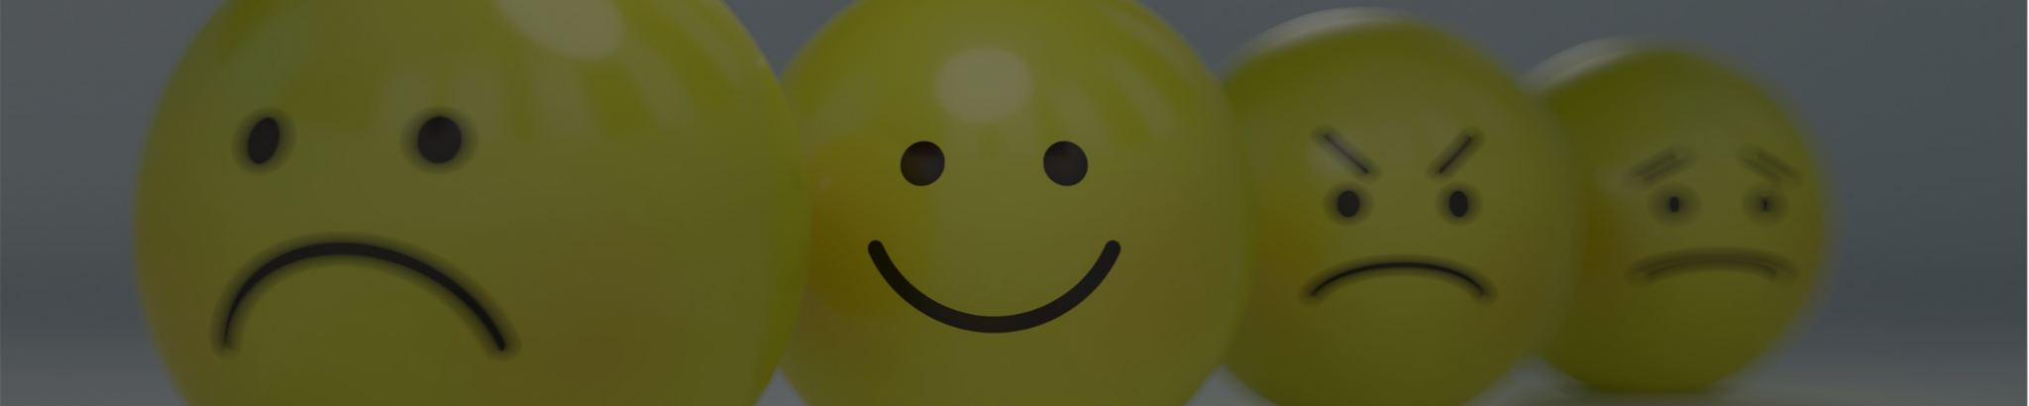

**References**

Below are the links to the various websites which were used

<https://github.com/sushassassin/Facial_emotions>

<https://www.c-sharpcorner.com/article/real-time-emotion-detection-using-python/>

<https://pypi.org/project/opencv-python/>

<https://opencv-python-tutroals.readthedocs.io/en/latest/py_tutorials/py_objdetect/py_face_detection/py_face_detection.html>

**Cost Analysis**

Since this Project only utilizes the software and no hardware is needed for it , financially the overall cost for the development was nil , everything needed such as software etc was obtained for free from the source websites

|  |  |  |
| --- | --- | --- |
| **S. No.** | **Component / Material** | **Price (in Rs.)** |
| 1. |  |  |
| 2. |  |  |
| 3. |  |  |
| 4. |  |  |
| 5. |  |  |
| 6. |  |  |
| **Total** | | **0.0**(₹)**/-** |



**ECE ARCHIVES PROJECT SUBMISSION FORM**

Project Code: **CU/ECE/20____/Sem /UID______________ (To be filled by Office)**

Project Name: ________________________________________

Name and UID of student: _________________________________

Team Members:

|  |  |  |  |  |
| --- | --- | --- | --- | --- |
| **S. No.** | **Name** | **UID** | **Semester** | **Contact No.** |
| 1. | Anmol Gupta | 19BEC1102 |  |  |
| 2. | Sushant Kumar | 19BEC1078 |  |  |
| 3. | Devesh Sehgal | 19BEC1082 |  |  |
| 4. | Paras Kumar | 19BEC1099 |  |  |
| 5. |  |  |  |  |

**Section to be filled by Project Mentor**

**Status (Please tick, whichever applicable)**

|  |  |  |  |
| --- | --- | --- | --- |
| Working |  | Not Working |  |
| **Marks Awarded** | | **60** |  |

Project Mentor Details:

Name _______________________________ Employee ID _______________

Sign ________________________________ Date ______________________

**Section to be filled by Project Examiner(s)**

**Status (Please tick, whichever applicable)**

|  |  |  |  |
| --- | --- | --- | --- |
| Working |  | Not Working |  |

Project Examiner Signatures:

Internal _______________________________ Employee ID ______________

External _______________________________ Employee ID ______________

Date __________________________________